STUDENT PERFORMANCE ANALYTICS SYSTEM
Project Documentation
Technology: Python, NumPy, Pandas
Project Type: Data Analysis
Project Title: Student Performance Analytics System
Student Name: Abhishek Maurya
Course/Class: Python with AI
Academic Year: 2026
Submission Date: 09/10/26

1. Project Objective
The objective of this project is to develop a Student Performance Analytics System using Python, NumPy, and Pandas.
The system processes student academic records, calculates total and average marks, assigns grades, determines Pass/Fail status, and analyzes overall class performance.
It also identifies the highest- and lowest-performing students, calculates subject-wise averages, analyzes attendance, displays the top five students, and saves the processed results in a CSV file.
2. Introduction
Student performance analysis helps understand individual academic progress and overall class performance.
Manually calculating student totals, averages, grades, and pass/fail results can be time-consuming. This project automates these tasks using Python programming and data analysis libraries.
The project demonstrates the practical use of Python fundamentals, reusable functions, loops, Pandas DataFrames, and NumPy numerical operations.
3. Technologies Used
- Python: Main programming language used to implement the system.
- Pandas: Used to load, process, organize, analyze, and save student data.
- NumPy: Used for numerical calculations, including mean, maximum, minimum, and standard deviation.
- CSV: Used to store the original student dataset and processed results.
- Visual Studio Code / Python IDE: [Enter the development environment you actually used.]
4. Dataset Description
The project uses a CSV dataset containing 20 student records.
The dataset contains the following columns:
Column | Description
Student_ID | Unique student identification number
Name | Name of the student
Department | Student's department
Python | Marks obtained in Python
Mathematics | Marks obtained in Mathematics
Statistics | Marks obtained in Statistics
Attendance | Student attendance percentage

The original dataset is stored in student.csv.
5. Project Structure
The project contains the following files:
- main.py — Main program responsible for loading data, processing records, performing analysis, displaying reports, and saving results.
- functions.py — Contains reusable functions for calculating totals, averages, grades, and Pass/Fail status.
- student.csv — Original student dataset.
- student_results.csv — Processed dataset containing calculated results.
- README.md — Project overview, instructions, features, and other documentation.
- .gitignore — Specifies files and folders that Git should ignore.
The __pycache__ folder may be created automatically by Python and is not required for the GitHub submission.
6. Implementation
6.1 Data Loading
Pandas is used to read the student dataset from the CSV file and store it in a DataFrame.
6.2 Total Marks Calculation
The total marks of each student are calculated by adding the marks obtained in Python, Mathematics, and Statistics.
Formula:
Total = Python + Mathematics + Statistics
6.3 Average Marks Calculation
The average marks are calculated by dividing the total marks by the number of subjects.
Formula:
Average = Total / 3
6.4 Grade Assignment
A reusable function assigns a grade based on the student's average marks.
6.5 Pass/Fail Checking
A student is considered to have passed if the student obtains at least 40 marks in each of the three subjects. Otherwise, the student is marked as Fail.
6.6 Use of Loops
A loop processes student records one by one to generate individual performance reports.
6.7 Use of Pandas
Pandas is used for reading CSV data, selecting columns, calculating results, sorting records, calculating statistics, and saving the final dataset.
6.8 Use of NumPy
NumPy is used for numerical analysis, including subject averages, maximum marks, minimum marks, and standard deviation.
7. Grade System
The project uses the following grading rules:
Average Marks | Grade
90 and above | A+
80 to below 90 | A
70 to below 80 | B
60 to below 70 | C
50 to below 60 | D
Below 50 | F
Pass Condition: A student must score at least 40 marks in every subject to receive Pass status.
8. Key Features
The system provides the following features:
- Loads student records from a CSV file.
- Displays student information and dataset statistics.
- Calculates total marks and average marks.
- Assigns grades automatically.
- Determines Pass/Fail status.
- Identifies the highest-performing student.
- Identifies the lowest-performing student.
- Calculates the overall class average.
- Calculates subject-wise average marks.
- Identifies the best-performing subject.
- Calculates the number of passed and failed students.
- Calculates Pass/Fail percentages.
- Displays the top five students based on average marks.
- Analyzes student attendance.
- Performs numerical analysis using NumPy.
- Saves the processed student results to a CSV file.
9. Analysis Performed
9.1 Student Performance Analysis
The system calculates total marks, average marks, grades, and Pass/Fail status for each student.
9.2 Class Performance Analysis
The system calculates the overall class average and identifies the highest- and lowest-performing students.
9.3 Subject-Wise Analysis
The system calculates average marks for Python, Mathematics, and Statistics and identifies the subject with the highest average.
9.4 Pass/Fail Analysis
The system calculates the number and percentage of students who passed or failed.
9.5 Attendance Analysis
The system calculates average, highest, and lowest attendance percentages.
9.6 Top Five Students
The system sorts student records by average marks in descending order and displays the top five students.
10. Output Screenshots
Screenshot 1: Individual Student Report
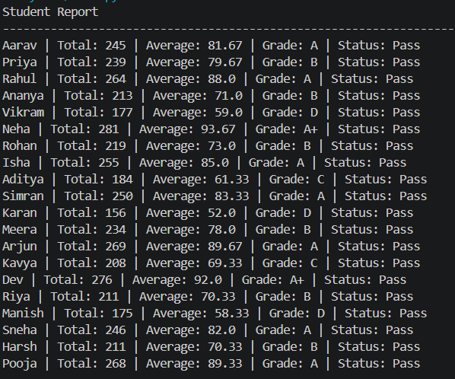
Screenshot 2: Processed Results Table
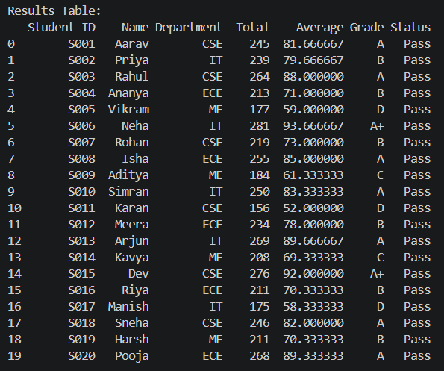
Screenshot 3: NumPy Analysis
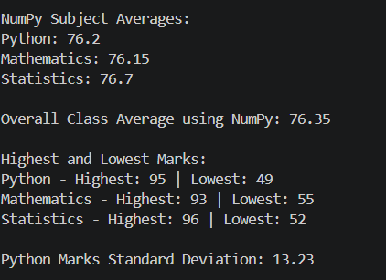
Screenshot 4: Attendance and Pass/Fail Analysis
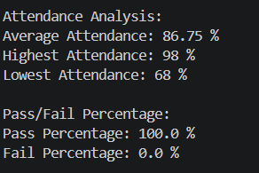
Screenshot 5: Top Five Students
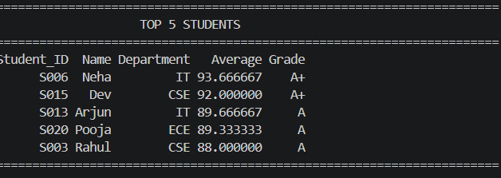
Screenshot 6: Final Performance Summary
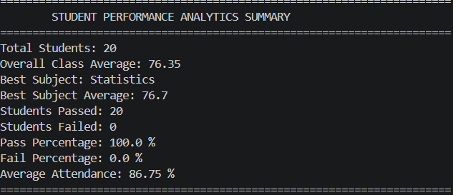
Screenshot 7: GitHub Repository
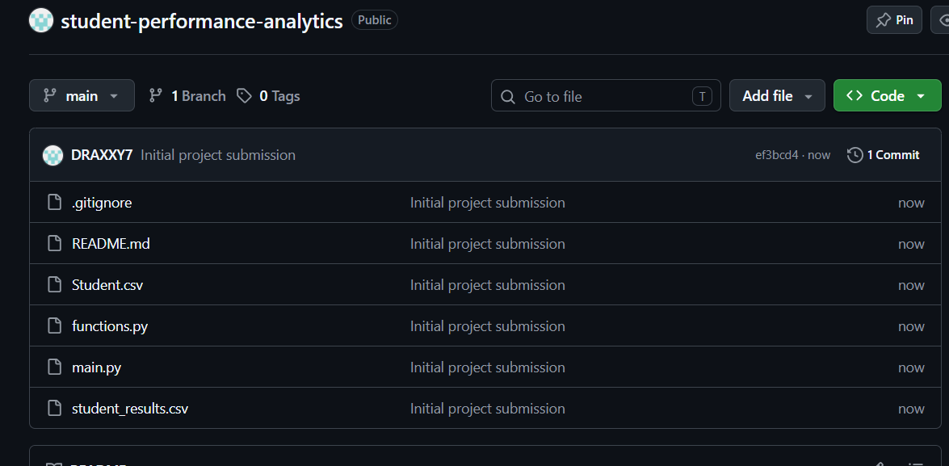
11. Output File
The program saves the processed dataset in student_results.csv.
The output file contains the original student information and the calculated columns:
- Total
- Average
- Grade
- Status
This allows the results to be reviewed later using spreadsheet software or Python.
12. Learning Outcomes
Through this project, I practiced:
- Python variables and data types.
- Conditional statements.
- Loops and iteration.
- Creating and using functions.
- Reading and writing CSV files.
- Working with Pandas DataFrames.
- Performing numerical calculations with NumPy.
- Sorting and analyzing datasets.
- Generating reports from structured data.
- Organizing a Python project into multiple files.
- Maintaining project files in a GitHub repository.
13. Challenges and Learning
During development, I learned how to organize reusable functions in a separate Python file and import them into the main program.
I also practiced loading CSV data, adding calculated columns to a DataFrame, applying conditional grading rules, and combining Pandas and NumPy in one project.
Testing and debugging helped me understand the importance of correct file names, consistent column names, and running the complete program before submission.
14. Final Outcome
The Student Performance Analytics System provides an automated method for processing and analyzing student academic data.
It calculates student totals and averages, assigns grades, checks Pass/Fail status, analyzes class and subject performance, evaluates attendance, and identifies the top-performing students.
The system also exports the processed results to a CSV file for further review.
15. GitHub Repository
Repository Name: student-performance-analytics
Repository URL: https://github.com/DRAXXY7/student-performance-analytics
16. Conclusion
This project demonstrates how Python, Pandas, and NumPy can be used to solve a practical data analysis problem.
It brings together programming fundamentals, data processing, numerical calculations, reusable functions, and report generation in a single application. The project also provides practical experience in documentation and version control using GitHub.

